Kevin Nunez 00323217 Linux Administration Adrianna Holden Gouveia 11/11/2026
In this lab we need to anticipate the problems that can occur with our server and check which part our system gets broken with the file break_system.sh that we are going to run in our virtual machine.
Important suggestions: Recommend that you make a backup copy of your virtual machines before running the script or doing any troubleshooting. It is very easy for things to go wrong and must start over.
The requirements for this lab are:
1. Troubleshooting: on each server, go through the troubleshooting steps you have learned to figure out what the issue is. Keep a troubleshooting log as you go: for each step, write down what you suspected, the command you ran, what it showed, and what you concluded. Include screenshots, and a screenshot of your history output on each server covering your troubleshooting session.
2. Fix: once you figure out what the issue is, explain how to solve it, including screenshots.
3. Automation: now that you have your problem solved, how could you turn your troubleshooting into a script? Create a script in the language of your choice that will help you troubleshoot this potential set of issues and test it on each server. The script must create a file with results that help you diagnose the issue.
4. Cron job: set up a cron job to run your troubleshooting script at specific intervals (daily, weekly, and/or monthly). Document how you set up the cron job and explain why you chose that frequency.
5. Emergency mode: write a one-page (or less) document on how to boot into emergency mode on each server. Include a 1 paragraph executive summary on why you might want to, and screenshots showing each step of the emergency boot process.
The first step is sharing our break_system.sh file to our server, when we get this file, we must give permission to run it, for this I use the command chmod 777.
After we get permission, we are going to run sudo ./break_system.sh we run it in admin mode because maybe some in the script need permission for be run.
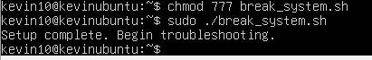

The first check after running the script, we are going to try ping a public address to check is the ping command is working, for this I run the command ping google.com
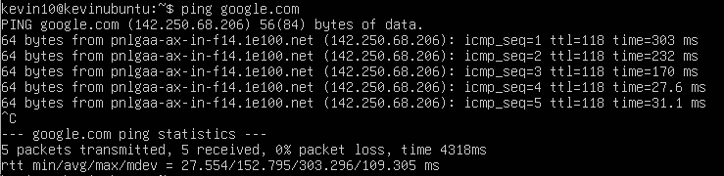
I can ping so my problem is not with the network.
For keep checking what else it can be breaking I going to run the command Ip a to check the Ip
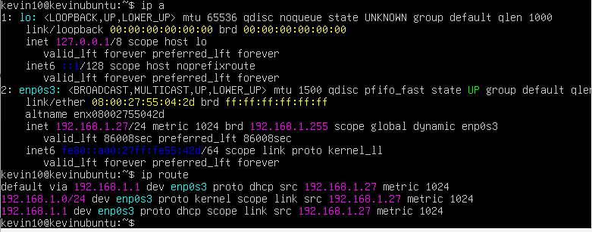
My Ip address is good, so this is not broken.
For check the permission of my machine I run the ls command and the sudo command.
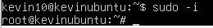
I don’t have problem with the permission so I am going to be good.

Now I run the command df -h to check the storage use and if something is going bad in the machine, for this we need to check the Use% column and the “/” symbol that have the partion of the storage.
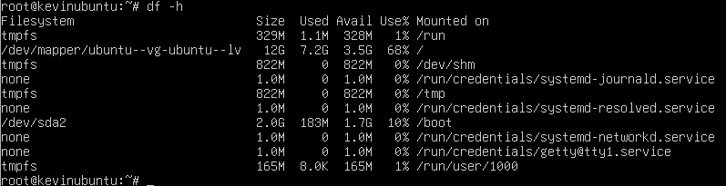
The storage is good, so we do not need to be worried about that now.
If we have something wrong with the storage, we can track the problem with the command du -sh /var/log/* /tmp/* | sort -h to check which files are taking too much space, if something is bad you going to find a file with the name /var/log/bigfile or /tmp/hugefile.
I rebooted the machine to check if maybe is something wrong with the system, and yes there I have the problem.
This is the Emergency mode and recovery system.
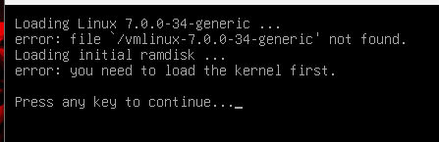
5. Booting into Emergency Mode (emergency.target) is a critical, absolute minimal operational framework used by administrators as an analytical tool of last resort. Unlike standard rescue modes, Emergency Mode boots the system by executing the Linux kernel with the absolute essentials: the root filesystem (/) is mounted strictly as read-only, networking run levels are completely disabled, and systemd avoids reading downstream disk points assigned in /etc/fstab. This mode is indispensable for resolving system boot stalls, structural failures within the GRUB environment, file mapping errors on core configuration blocks, or storage mounting loops preventing normal target completion.

Step 1: Access the GRUB Boot Selection Display
Reboot or power up the guest virtual machine.
Now we need to hit the Esc key repeatedly (on CentOS environments, in Ubuntu is just press a key) to trap the system initialization thread and call up the primary GRUB selection screen.
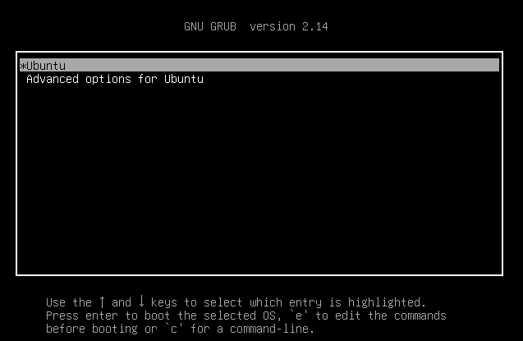
Step 2: Access Parameter Code Modifications
Utilize the directional arrow keyboard options to emphasize and select your principal operational Linux distribution kernel.
Press the e key on the terminal keyboard to suspend automatic execution and open the localized script editor module interface.

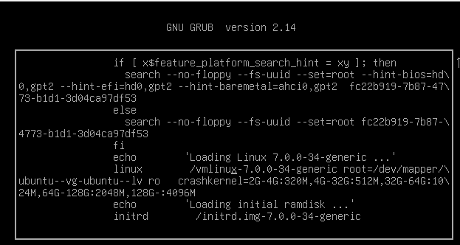
Step 3: Insert the Target Runlevel Parameter Rule
Navigate downwards using the arrow keys to locate the configuration argument instruction line starting with the word keyword linux or linux16 (this sequence contains system commands like ro, quiet, splash, or rhgb quiet).
On the “/vmlinux-7.0.0-34-generic root=/dev/mapper/\” we change the linux to linuz and we press CTRL + X.
Step 5: Remount the Filesystem Layer to Apply Changes
Now the machine start working but with a corruct dev-sda99.device/start, so we wait the 1 minute and 30 second, after that we go into root mode in the emergency system for repair this problem, for that we run the command sudo dpkg –configure -a, sudo apt install -f, sudo apt update && sudo apt upgrade -y , and sudo update-grub.
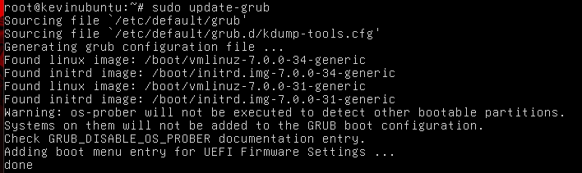
Step 4: Direct System Execution Init Run
Now we need to erase the warning of sda99, for this we run the command sudo nano /etc/fstab.
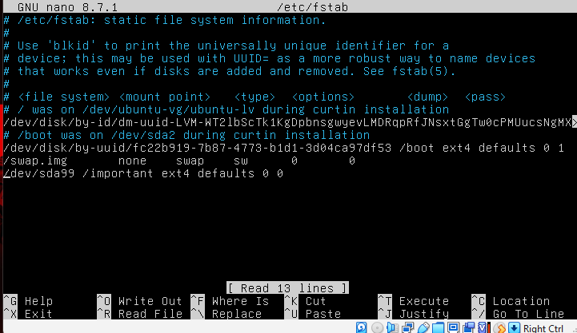
Here we put a # comment in front of the /dev/sda99 file for taking that out.
After we save the changes with the command CTRL + O and then ENTER, and exit with CTRL + X,
After these steps we type reboot to check if everything is going well.
Now we gave the permission to the Check-script.sh script with chmod 777 and then we run it with ./Check-script.sh
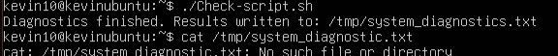
We check the file in the /tmp/system_diagnostic.txt
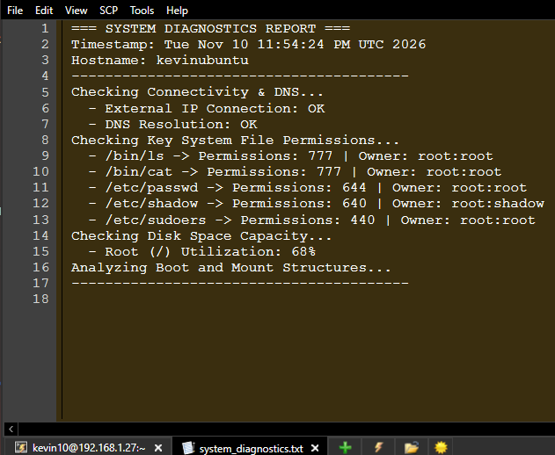

Check-script.sh
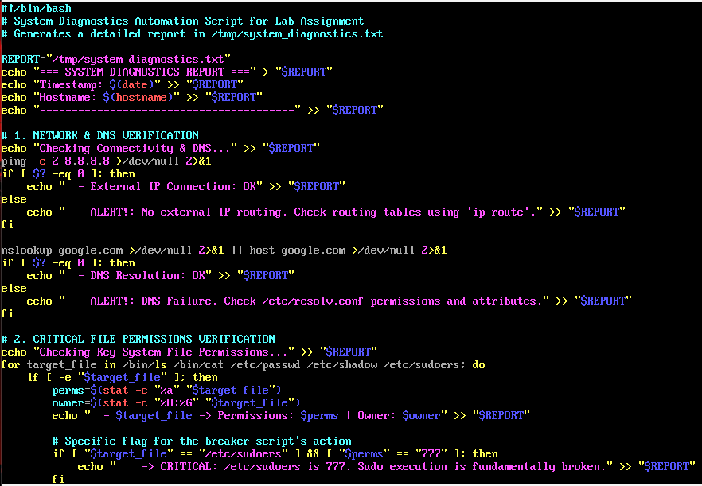
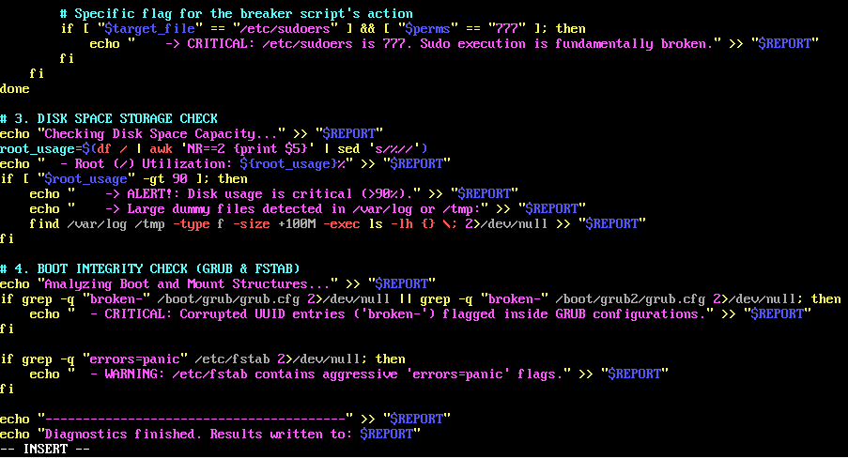

Now for make the cron job, for check the system without broke the system or checking by me every day, we run the in-root mode the command sudo crontab -e, assuming you save the file in /usr/local/bin/ the command is 0 1 * * * /usr/local/bin/Check-script.sh > /dev/null 2>&1.
This configuration is daily because these types of failures like full storage, infinity logs, wrong applications, or permission change can occur in daily production. Executing at 1:00 AM ( 01 **) is better for the charge of the server, minimizing the impact of the production.

GitHub: https://github.com/kevinNunez137/Linux-Administration

References:
https://www.aholdengouveia.name/LinuxAdmin/serversecurity.html
youtube.com/watch?v=s5uw5BiKehg&time_continue=3&source_ve_path=MjM4NTE&embeds_referring_euri=https%3A%2F%2Fnecc.brightspace.com%2F
https://web.archive.org/web/20220607232203/https://www.networkworld.com/article/3330497/linux-commands-for-measuring-disk-activity.html
https://web.archive.org/web/20221012133324/https://www.linuxfoundation.org/blog/blog/classic-sysadmin-linux-101-5-commands-for-checking-memory-usage-in-linux
https://web.archive.org/web/20220510004952/https://www.networkworld.com/article/3428361/how-to-manage-logs-in-linux.html
https://ncp.nist.gov/repository
https://www.freedesktop.org/software/systemd/man/systemd.special.html
https://man7.org/linux/man-pages/man5/crontab.5.html
https://man7.org/linux/man-pages/man5/fstab.5.html
https://ubuntu.com/server/docs/explanation/networking/configuring-networks/
https://docs.centos.org/
https://docs.redhat.com/en/documentation/red_hat_enterprise_linux/6/html/deployment_guide/sec-emergency_mode
https://www.gnu.org/software/bash/manual/bash.html
https://www.gnu.org/software/coreutils/manual/coreutils.html

